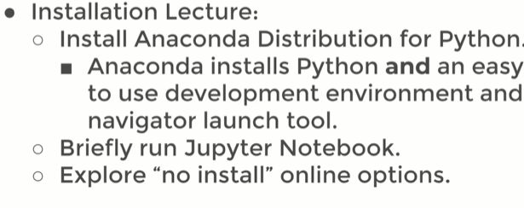
When You open Anaconda as a administrator.
You’ll have a enviorment tabs which is a virtual enviorment allows you to create a virtual enviorment seperate from your base enviorment to install particular version of libraries.
Google search anacondo.com downloads
Jupyter doesnt require the internet to run, its using your browser as a visual interface to right code in.

